AI ASSIGNMENT-9.1
NAME:PENNA BHARGAVI
BATCH:44
2303A52391
Problem 1:
Consider the following Python function:
def find_max(numbers):
return max(numbers)

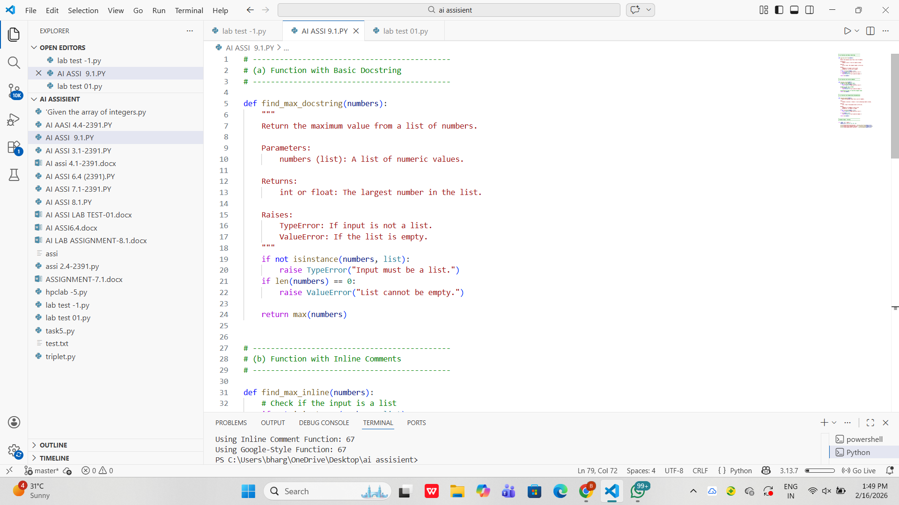

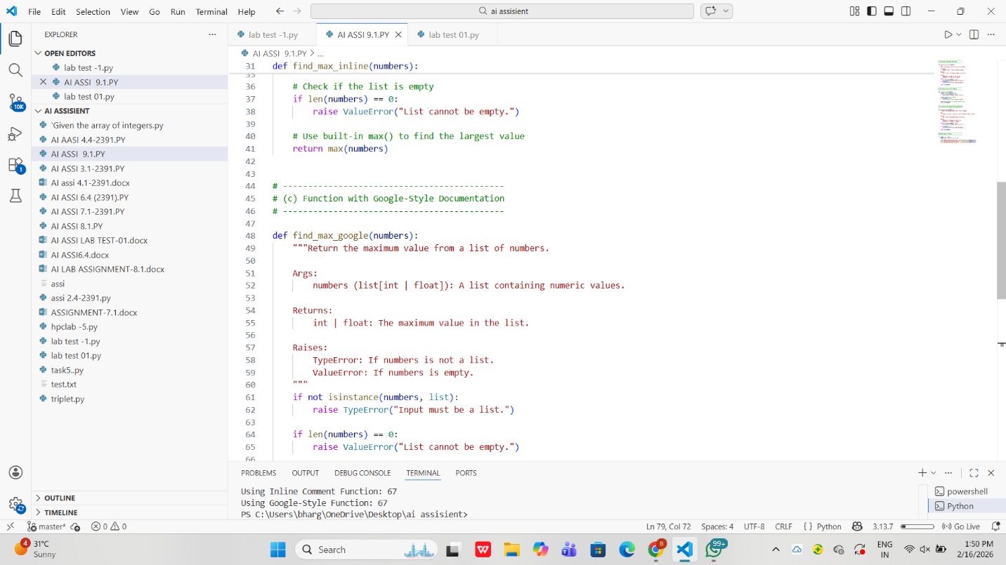
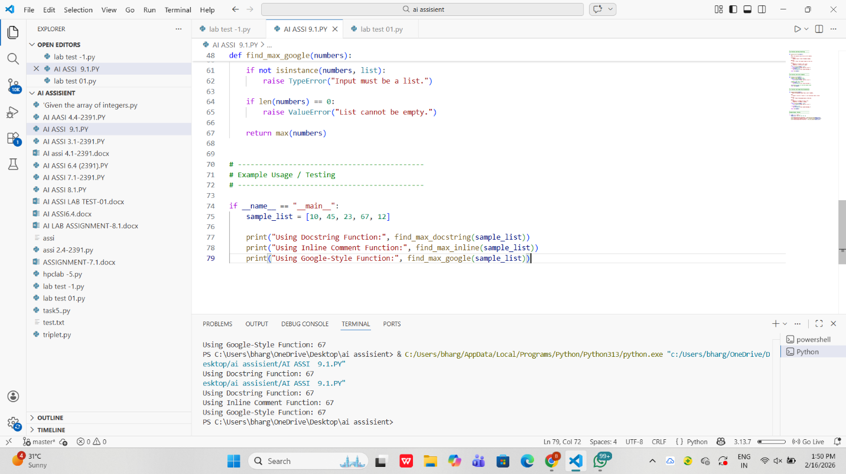

OBSERVATION:
1. The function was documented using docstring, inline comments, and Google-style format.
2. Docstrings allow automatic documentation generation using tools like pydoc.
3. Inline comments improve immediate code understanding but are not included in generated documentation.
4. Google-style documentation provides clear structure with parameters and return details.
5. For a mathematical utilities library, Google-style docstrings are most effective due to clarity, consistency, and professional documentation standards.

Problem 2: Consider the following Python function:
def login(user, password, credentials):
return credentials.get(user) == password

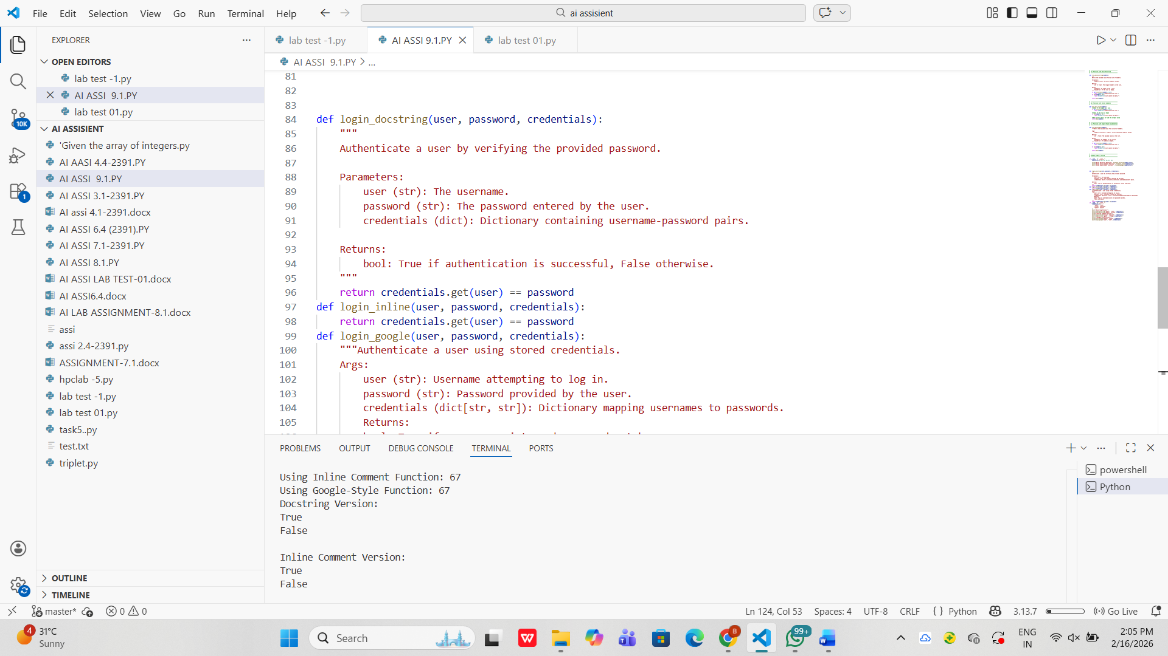

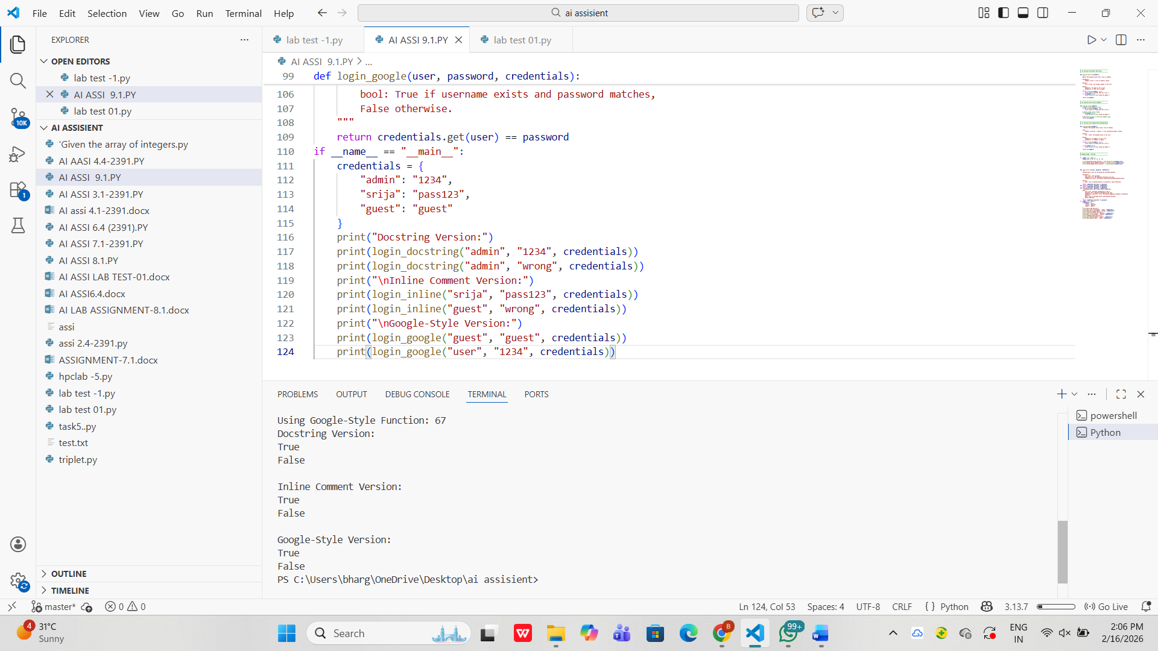
OBSERVATION:
1. The login() function was documented in three formats: docstring, inline comments, and Google-style.
2. Docstrings support automatic documentation generation.
3. Inline comments improve readability but are not part of generated docs.
4. Google-style documentation is clear and well-structured.
5. Google-style is most helpful for new developers due to better clarity.

Problem 3: Calculator (Automatic Documentation Generation)
Task: Design a Python module named calculator.py and
demonstrate automatic documentation generation.

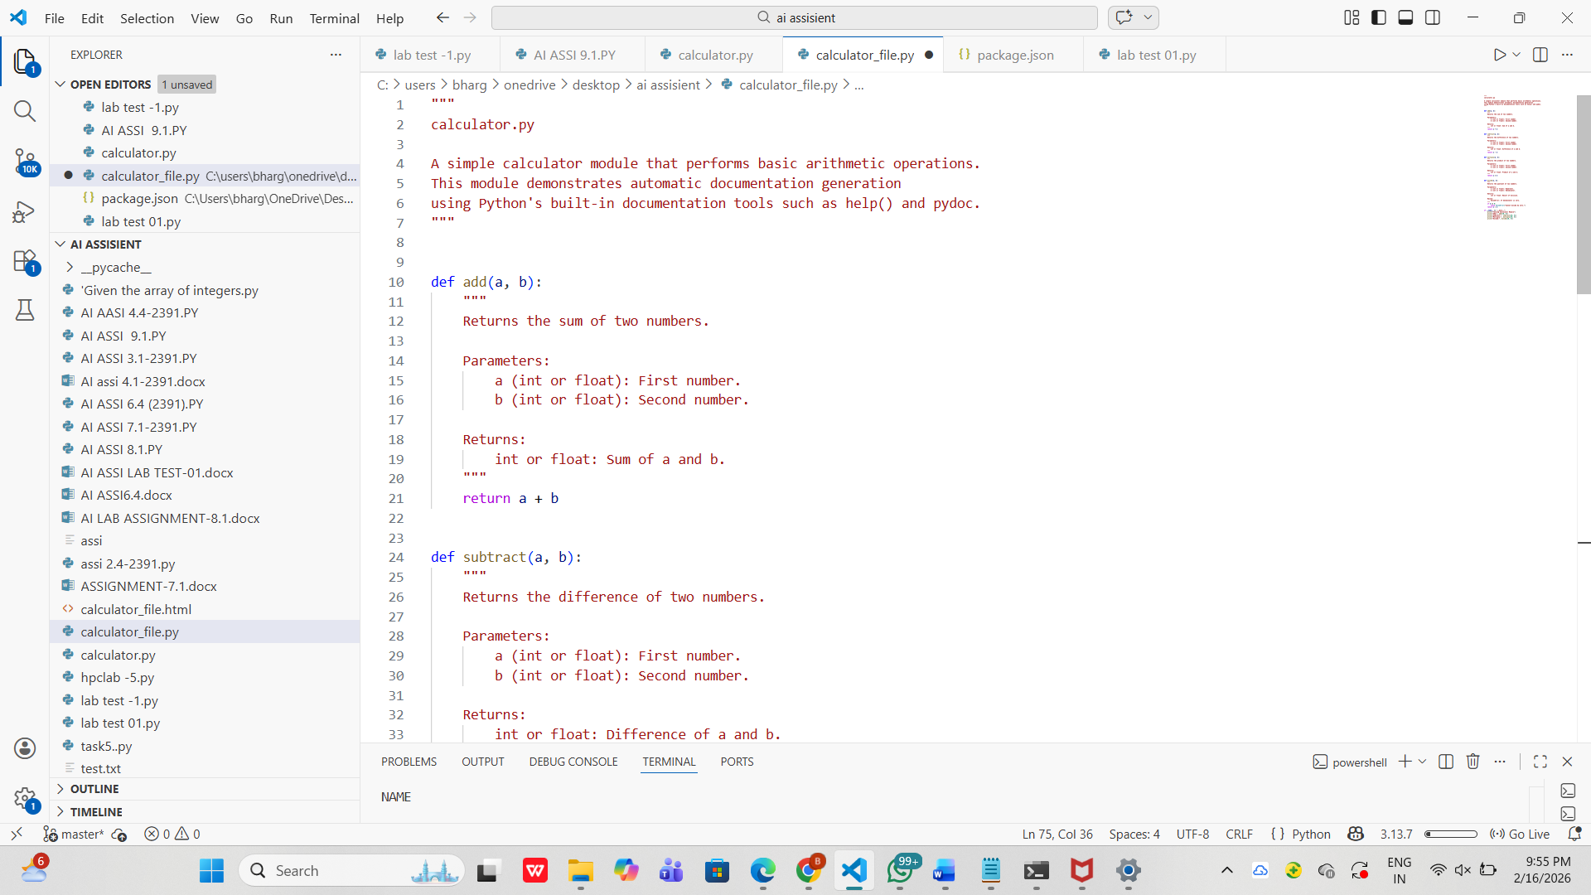
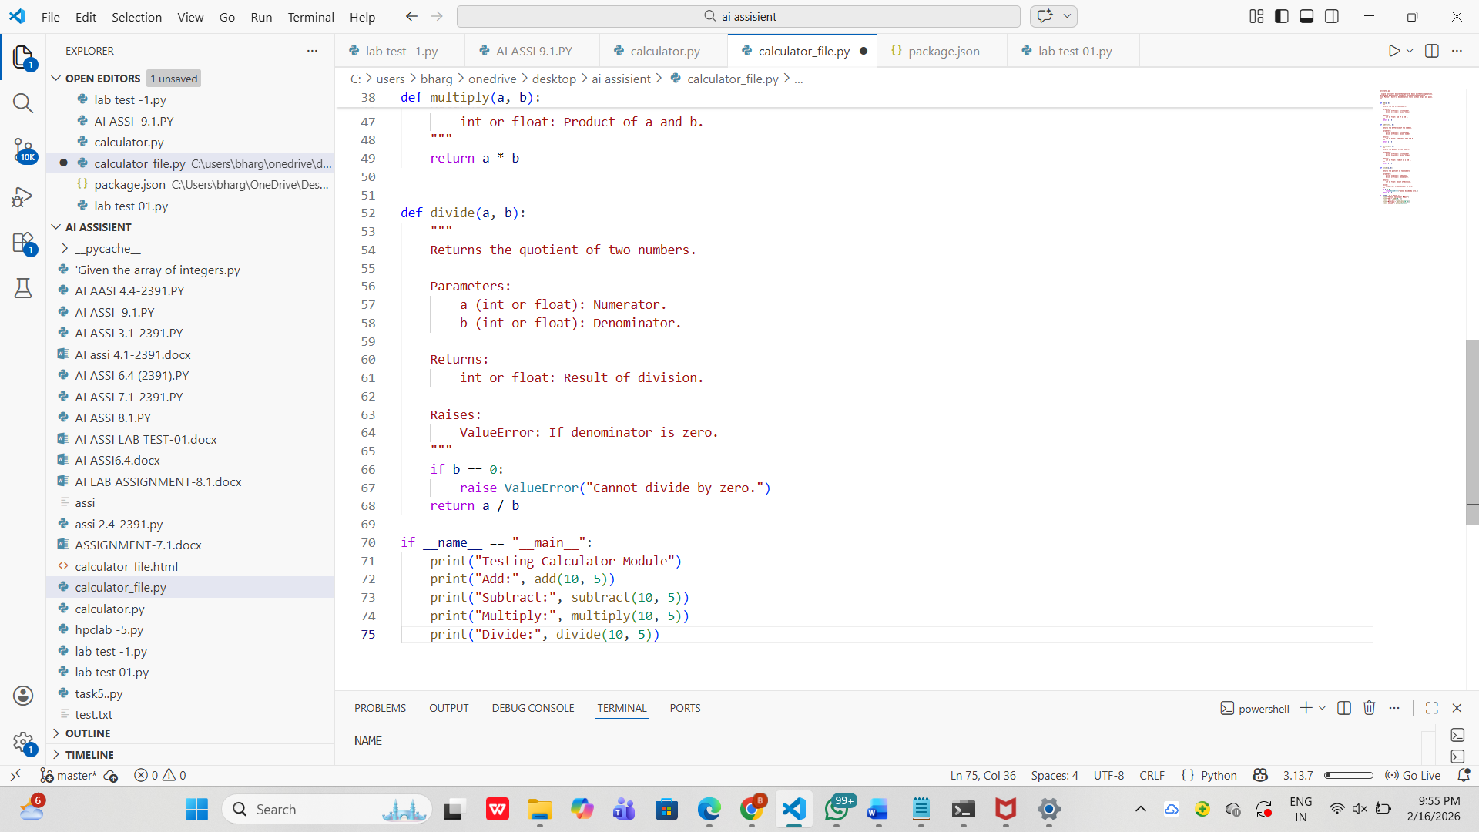

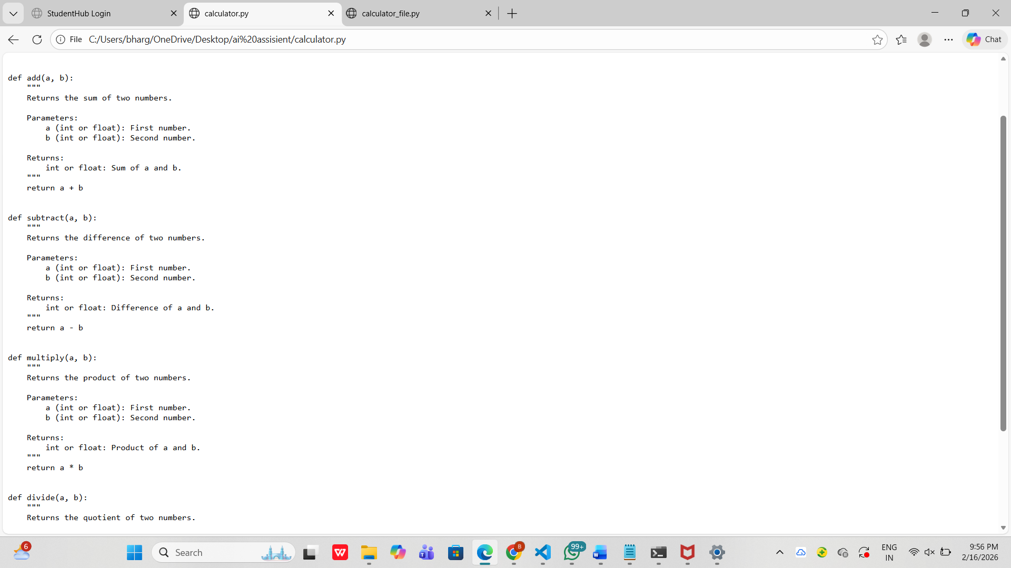
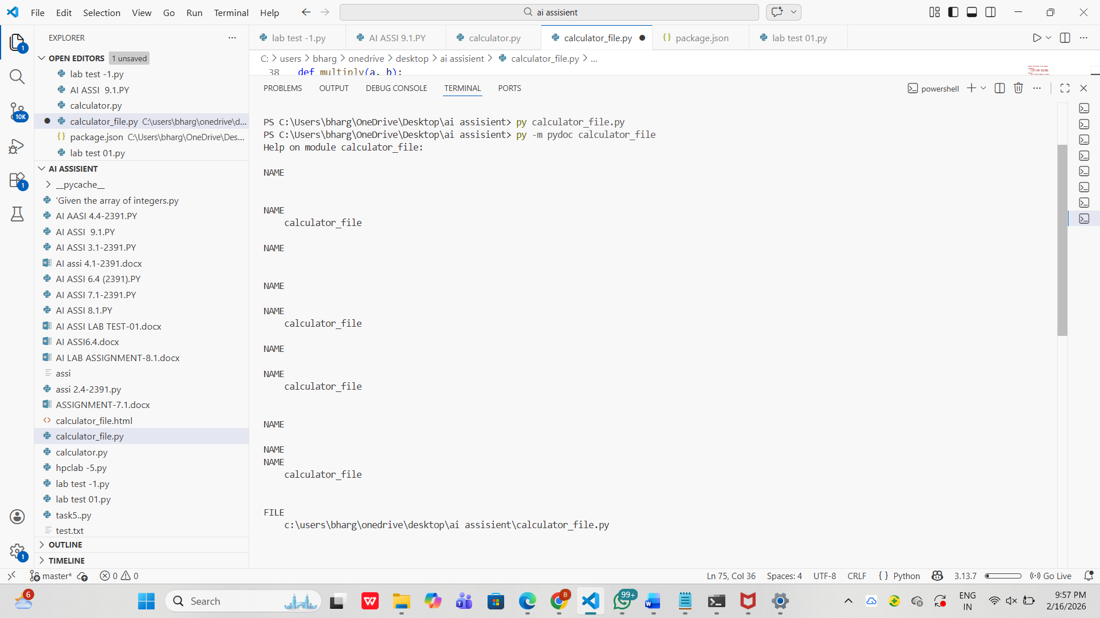

OBSERVATION:
1. The calculator.py module was successfully created with the functions add(), subtract(), multiply(), and divide().
2. Proper docstrings were written for each function, enabling automatic documentation generation.
3. The module documentation was correctly displayed in the terminal using Python’s built-in pydoc.
4. The HTML documentation file was successfully generated using the pydoc -w command.
5. The generated HTML file opened in the browser and clearly displayed module and function details.

Problem 4: Conversion Utilities Module
Task:
1. Write a module named conversion.py with functions:
o decimal_to_binary(n)
o binary_to_decimal(b)
o decimal_to_hexadecimal(n)
2. Use Copilot for auto-generating docstrings.
3. Generate documentation in the terminal.
4. Export the documentation in HTML format and open it in a
browser.
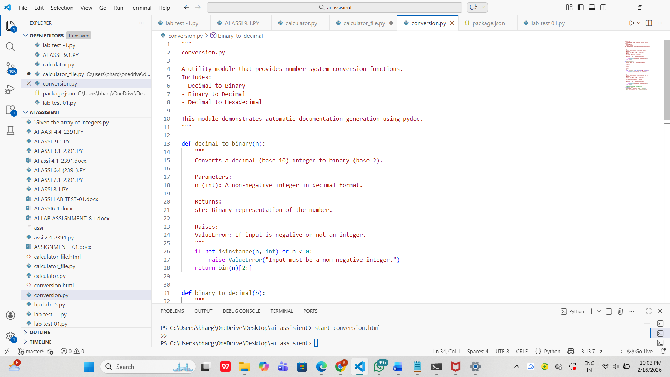
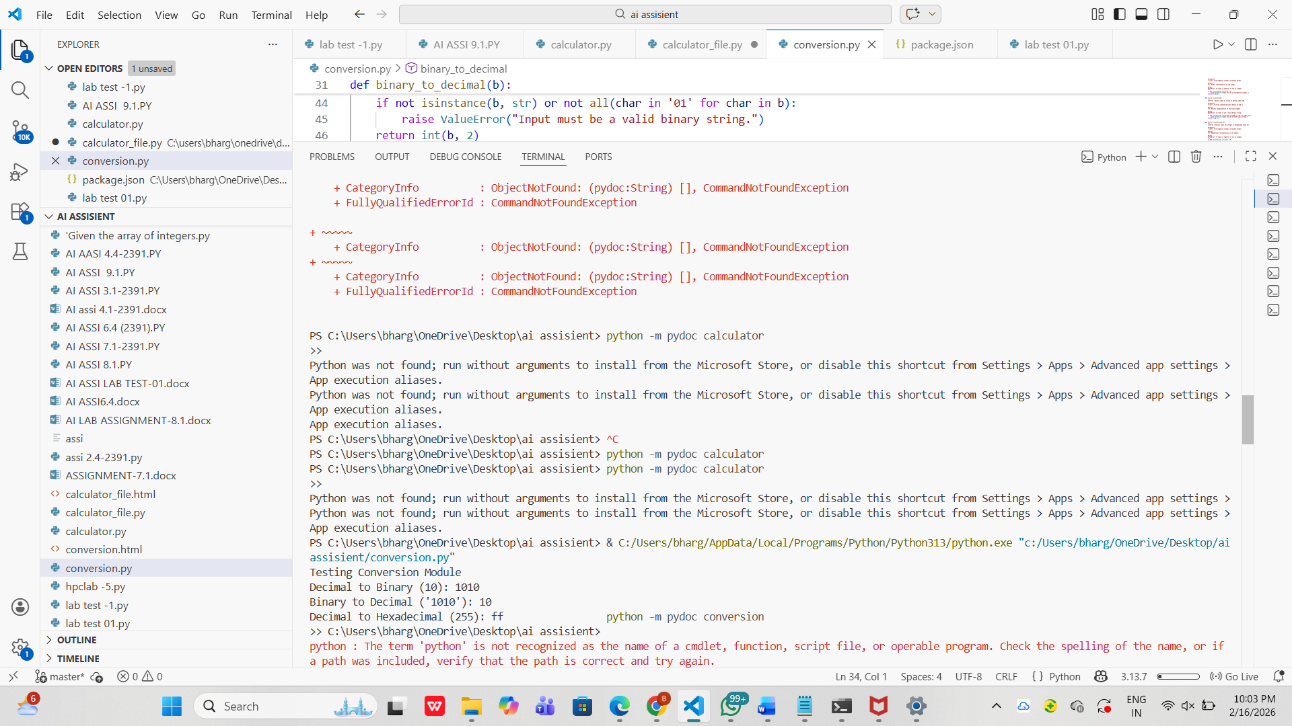

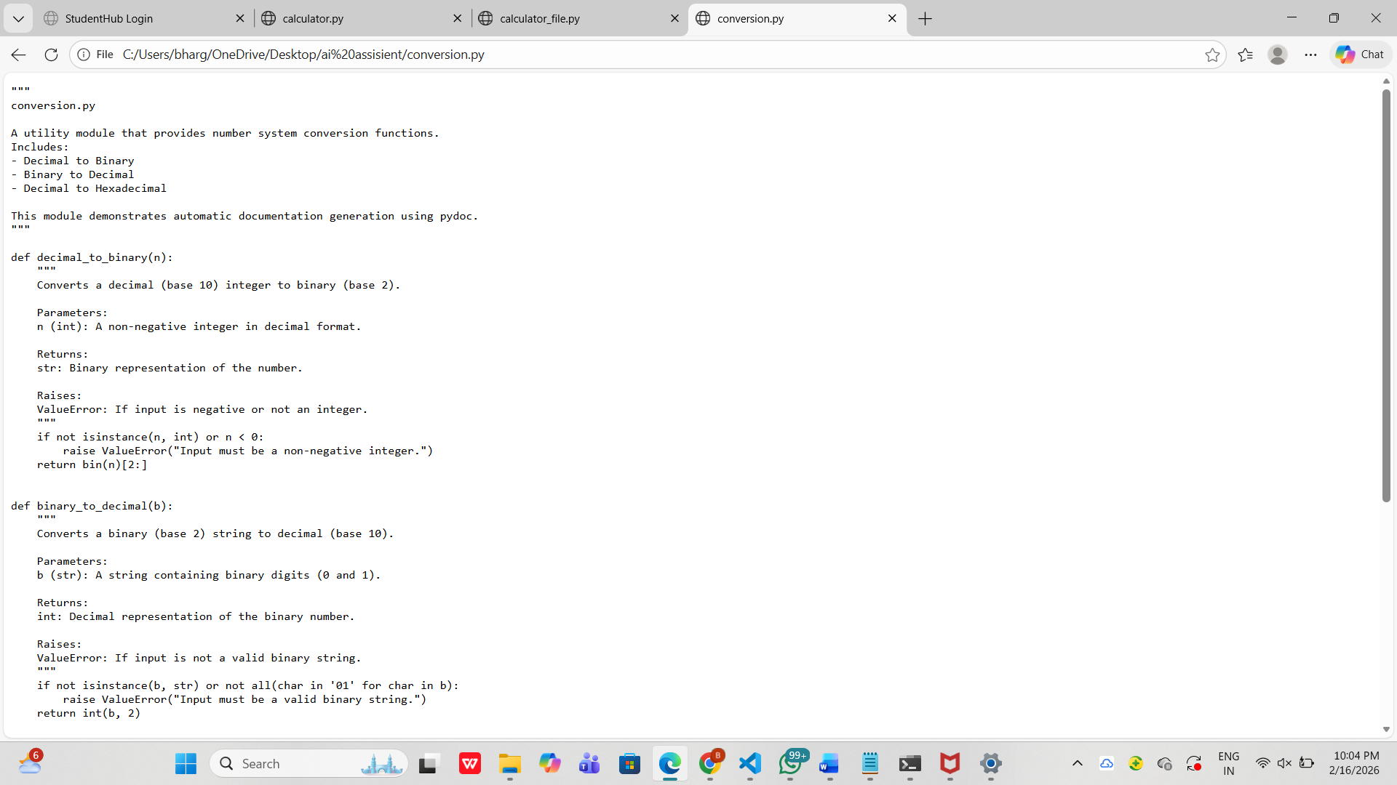

OBSERVATION:
1 .The conversion.py module was successfully created with the required conversion functions.
2. GitHub Copilot assisted in generating clear and structured docstrings for each function.
3. All conversion functions worked correctly for valid inputs and handled invalid inputs safely.
4. Documentation was successfully displayed in the terminal using Python’s built-in pydoc module.
5. The documentation was exported to an HTML file and opened in a web browser, confirming successful automatic documentation generation.

Problem 5 – Course Management Module
Task:
1. Create a module course.py with functions:
o add_course(course_id, name, credits)
o remove_course(course_id)
o get_course(course_id)
2. Add docstrings with Copilot.
3. Generate documentation in the terminal.
4. Export the documentation in HTML format and open it in a
browser.
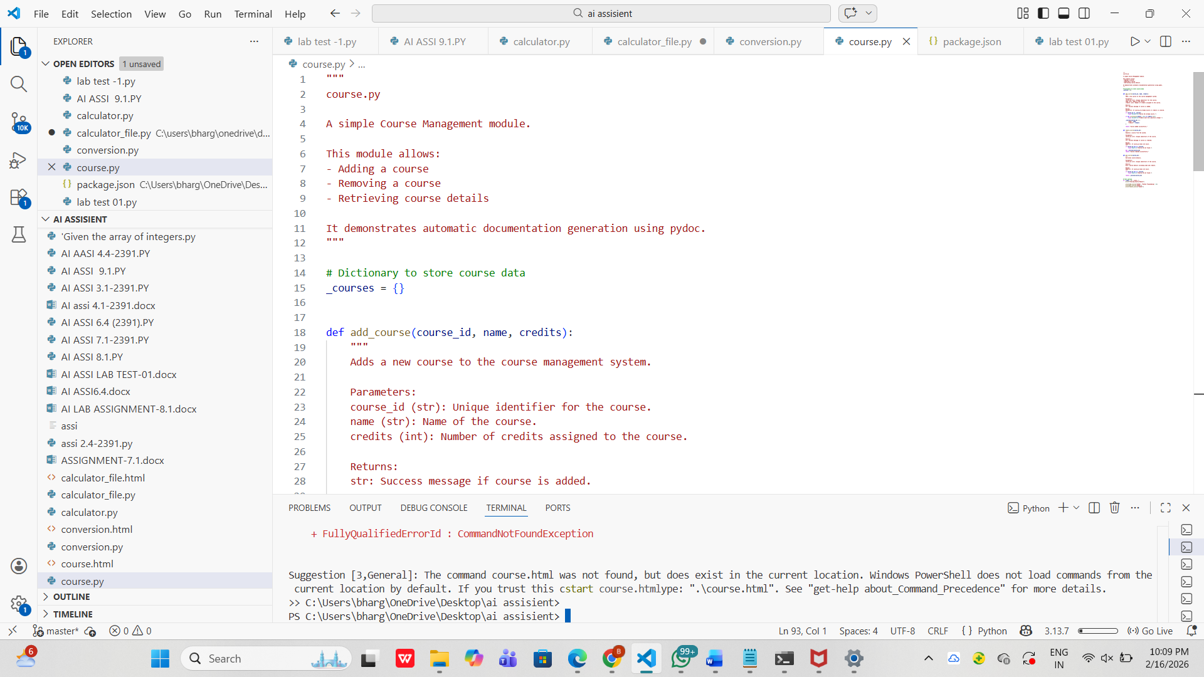

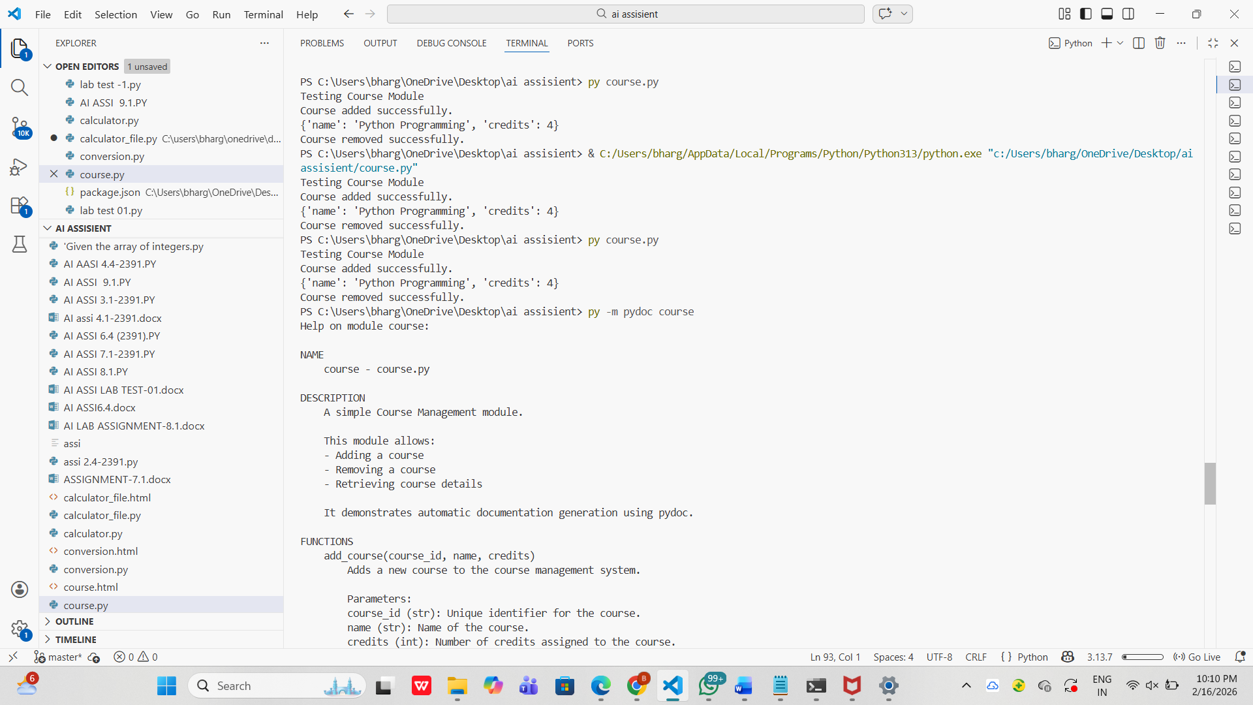
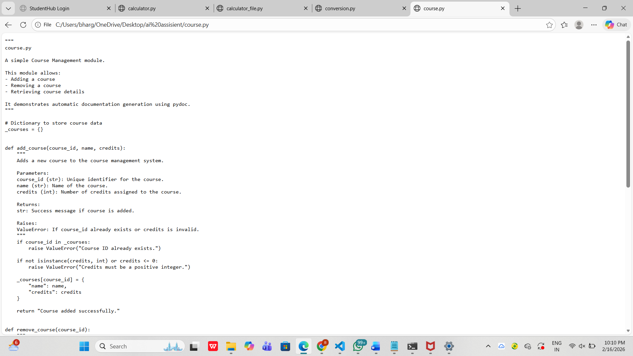

OBSERVATION:
. The course.py module was successfully created with the required functions: add_course(), remove_course(), and get_course().
2.Proper docstrings were added to all functions, enabling automatic documentation generation.
3. The module handled errors effectively using appropriate exceptions (ValueError, KeyError).
4. Documentation was successfully generated in the terminal using the built-in Python module pydoc.
5. HTML documentation was generated and opened in a web browser, confirming that automatic documentation export works correctly.

